**Project Name: Diagnostic Center Bill Management System**

**Pages which we tested**

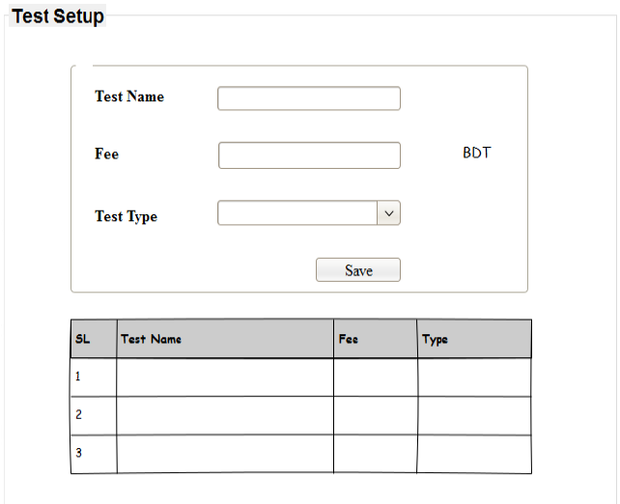

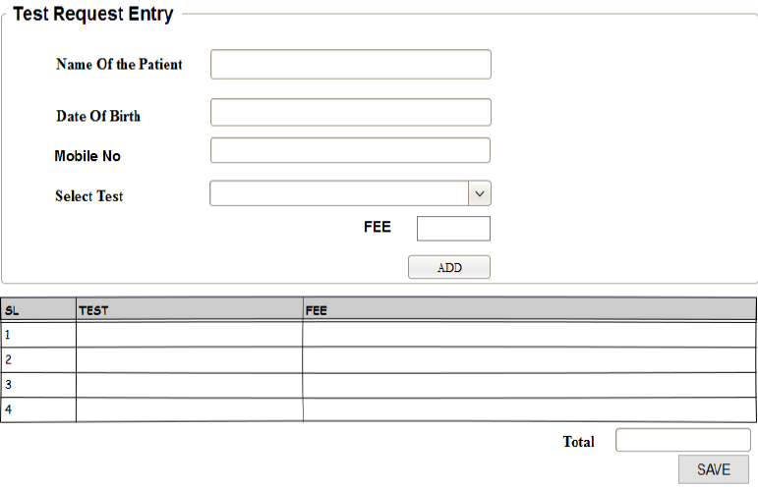

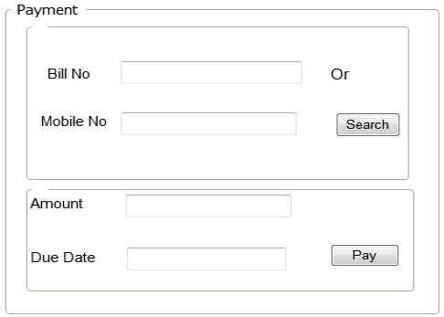

**Test Case Design**

Test Case 1: Insert Test Details

|  |  |  |  |  |  |
| --- | --- | --- | --- | --- | --- |
| Step | Test Steps | Test Data | Expected Results | Actual Result | Status (Pass/Fail) |
| 1 | Provide Test name and Fee | Lipid Profile  450  Blood | Provided data will be saved in database and will show “Test Saved Successfully” message | “Test Saved Successfully” | Pass |
| 2 | Select a type of the test |
| 3 | Check test name in existing database |
| 4 | Click “Save” |

Test Case 2: Insert Test Details with an Empty field

|  |  |  |  |  |  |
| --- | --- | --- | --- | --- | --- |
| Step | Test Steps | Test Data | Expected Results | Actual Result | Status (Pass/Fail) |
| 1 | Do not provide all information about a test | Feet X-ray  X-ray | Error message “required” will show below the input field Fee | “Required” | Pass |
| 2 | Click “Save” |

Test Case 3: Insert Test Details which is existing

|  |  |  |  |  |  |
| --- | --- | --- | --- | --- | --- |
| Step | Test Steps | Test Data | Expected Results | Actual Result | Status (Pass/Fail) |
| 1 | Provide a Test name which is already exist in database | Lipid Profile  450  Blood | Error message will show “Test name is already saved” | “Test Name is already Saved” | Pass |
| 2 | Input Fee |
| 3 | Select a type of the test |
| 4 | Click “Save” |

Test Case 4: Test Request Entry

|  |  |  |  |  |  |
| --- | --- | --- | --- | --- | --- |
| Step | Test Steps | Test Data | Expected Results | Actual Result | Status (Pass/Fail) |
| 1 | Provide Patient Name, Date of Birth, Mobile No | Nafis Iqbal  1997-02-07  01982610143  Lipid Profile | Selected test will be shown in a data grid view with total bill after click “Add’.  All data will be saved in database and a PDF will be created which contain all the details with total bill with a unique bill number after click “Save” | Grid view of the selected test and total bill 450 after click “Add”.  PDF Generated. | Pass |
| 2 | Select a test |
| 3 | Click “Add” |
| 4 | Click “Save” |

Test Case 5: Test Request Entry with an empty field

|  |  |  |  |  |  |
| --- | --- | --- | --- | --- | --- |
| Step | Test Steps | Test Data | Expected Results | Actual Result | Status (Pass/Fail) |
| 1 | Do not provide all information about patient | Lipid Profile  450  Blood | Error message “Required” will show after click “Add” or “Save” below the empty input field. | “Required” | Pass |
| 2 | Select a test |
| 3 | Click “Add” |
| 4 | Click “Save” |

Test Case 6: Search Bill by Bill No

|  |  |  |  |  |  |
| --- | --- | --- | --- | --- | --- |
| Step | Test Steps | Test Data | Expected Results | Actual Result | Status (Pass/Fail) |
| 1 | Provide Bill No | 106 | Total Bill and Due Date will be shown. | 1150  28/7/2018 | Pass |
| 2 | Click “Search” |

Test Case 7: Search Bill by Mobile No

|  |  |  |  |  |  |
| --- | --- | --- | --- | --- | --- |
| Step | Test Steps | Test Data | Expected Results | Actual Result | Status (Pass/Fail) |
| 1 | Provide Mobile No | 01982610143 | Total Bill and Due Date will be shown. | 1150  28/7/2018 | Pass |
| 2 | Click “Search” |

Test Case 8: Payment

|  |  |  |  |  |  |
| --- | --- | --- | --- | --- | --- |
| Step | Test Steps | Test Data | Expected Results | Actual Result | Status (Pass/Fail) |
| 1 | Click “Pay” | 106 | Will show message “Payment Successful” and data will be deleted from database for bill no 106. | “Payment Successful” | Pass |

Test Case 9: Check Bill no which is already paid

|  |  |  |  |  |  |
| --- | --- | --- | --- | --- | --- |
| Step | Test Steps | Test Data | Expected Results | Actual Result | Status (Pass/Fail) |
| 1 | Provide Bill No or Mobile No | 106  01982610143 | Will show message “No unpaid bill information found for this bill no or mobile no” | “No unpaid bill information found for this bill no or mobile no” | Pass |
| 2 | Click “Search” |

**Requirement Traceability Matrix**

|  |  |  |  |  |  |  |  |  |  |  |
| --- | --- | --- | --- | --- | --- | --- | --- | --- | --- | --- |
|  | TC_1 | TC_2 | TC_3 | TC_4 | TC_5 | TC_6 | TC_7 | TC_8 | TC_9 | Number of Test cases for respective requirement ↓ |
| Insert test details | √ | √ | √ |  |  |  |  |  |  | **3** |
| Request Entry |  |  |  | √ | √ |  |  |  |  | **2** |
| Search Bill Information |  |  |  |  |  | √ | √ |  | √ | **3** |
| Payment |  |  |  |  |  |  |  | √ |  | **1** |

**All Pair Testing**

**Test Setup Form**

|  |  |  |
| --- | --- | --- |
| Test Name | Fee | Test Type |
| Char | Char | Char |
| Char | Int | Char |
| Char | Null | Char |
| Int | Char | Char |
| Int | Int | Char |
| Int | Null | Char |
| Char | Char | Null |
| Char | Int | Null |
| Char | Null | Null |
| Null | Char | Null |
| Null | Int | Null |
| Null | Null | Null |
| Int | Char | Null |
| Int | Int | Null |
| Int | Null | Null |
| Null | Char | Char |
| Null | Int | Char |
| Null | Null | Char |

**Test Request Entry Form**

|  |  |  |  |
| --- | --- | --- | --- |
| Patient Name | Date of Birth | Mobile No | Test Name |
| Char | Char | Char | Char |
| Char | Char | Int | Char |
| Char | Char | Null | Char |
| Char | Int | Char | Char |
| Char | Int | Int | Char |
| Char | Int | Null | Char |
| Char | Char | Char | Null |
| Char | Char | Int | Null |
| Char | Char | Null | Null |
| Char | Int | Char | Null |
| Char | Int | Int | Null |
| Char | Int | Null | Null |
| Char | Null | Char | Char |
| Char | Null | Int | Char |
| Char | Null | Null | Char |
| Char | Null | Char | Null |
| Char | Null | Int | Null |
| Char | Null | Null | Null |
| Int | Char | Char | Char |
| Int | Char | Int | Char |
| Int | Char | Null | Char |
| Int | Int | Char | Char |
| Int | Int | Int | Char |
| Int | Int | Null | Char |
| int | Char | Char | Null |
| Int | Char | Int | Null |
| Int | Char | Null | Null |
| Int | Int | Char | Null |
| Int | Int | Int | Null |
| Int | Int | Null | Null |
| Int | Null | Char | Char |
| Int | Null | Int | Char |
| Int | Null | Null | Char |
| Int | Null | Char | Null |
| Int | Null | Int | Null |
| Int | Null | Null | Null |
| Null | Char | Char | Char |
| Null | Char | Int | Char |
| Null | Char | Null | Char |
| Null | Int | Char | Char |
| Null | Int | Int | Char |
| Null | Int | Null | Char |
| Null | Char | Char | Null |
| Null | Char | Int | Null |
| Null | Char | Null | Null |
| Null | Int | Char | Null |
| Null | Int | Int | Null |
| Null | Int | Null | Null |
| Null | Null | Char | Char |
| Null | Null | Int | Char |
| Null | Null | Null | Char |
| Null | Null | Char | Null |
| Null | Null | Int | Null |
| Null | Null | Null | Null |

**Bill Search Form**

|  |  |
| --- | --- |
| Bill No | Mobile No |
| Char | Null |
| Char | Char |
| Char | Int |
| Null | Null |
| Null | Char |
| Null | Int |
| Int | Null |
| Int | Char |
| Int | Int |